Training and User Manual

Document history

|  |  |  |  |  |
| --- | --- | --- | --- | --- |
| Version | Date | Author | Changes | Valid from |
| 1.0 | 29-Sep-2016 | Hardik Kansara |  |  |

Table of Contents

1 Installation 3

1.1 Step 1 : Run the installer 3

1.2 Step 2 : Follow the instructions of the installer until the end 3

1.3 Step 3 : Navigate to where the application was installed. For example: C:\Program Files (x86)\Weltec Project\Database Evaluator Client 5

1.4 Step 4 : Run the application as an administrator 5

2 Running the Application 6

2.1 Step 1 : Start DBEvaluation on Client Database System. (Run the application under administrator account who has full access on SQL Server instance.) 6

2.2 Step 2 : Initial loading screen. 6

2.3 Step 3 : Main Screen and SQL Server instance selection. 7

2.4 Step 4 : User Database selection (Optional) 8

2.5 Step 5 : Start gathering parameters values. 9

2.6 Step 6 : Saving of dump file. 9

3 Website

1. Open browser……………………………………………………………………………………………..11

2. Go to the website……………………………………………………………………………………….11

3. Home Page………………………………………………………………………………………………….11

4. Documentation Page………………………………………………………………………………….13

5. Download Page……………………………………………………………………………………………15

6. Contact Us Page………………………………………………………………………………………….16

7. About Page………………………………………………………………………………………………….17

8. Register Page……………..………………………………………………………………………………18

9. Register Confirmation Email………………………………………………………………………18

10. Login Page…………………………………………………………………………………………………..19

11. Add Menu Upload…………………………………………………………………………………………19

12. Upload Form……………………………………………………………………………………………….20

13. Select .dbe File……………………………………………………………………………………………20

14. Uploading .dbe File………………………………………………………………………………………21

15. Finish Uploading .dbe File……………………………………………………………………………21

16. Uploaded Email Report to User……………………………………………………………………22

17. Table Report Page……………………………………………………………………………………….22

# Installation

## Step 1 : Run the installer



## Step 2 : Follow the instructions of the installer until the end

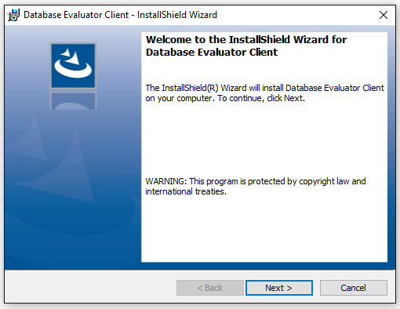

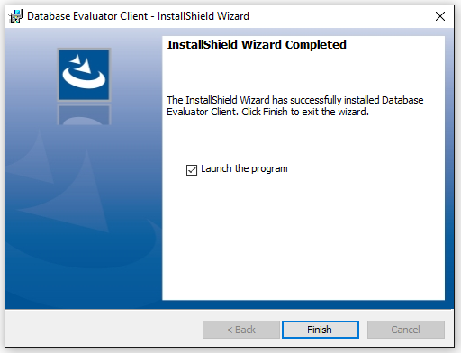

## Step 3 : Navigate to where the application was installed. For example: C:\Program Files (x86)\Weltec Project\Database Evaluator Client

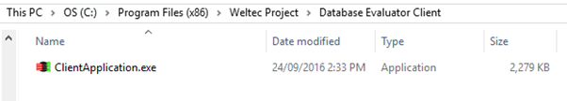

## Step 4 : Run the application as an administrator

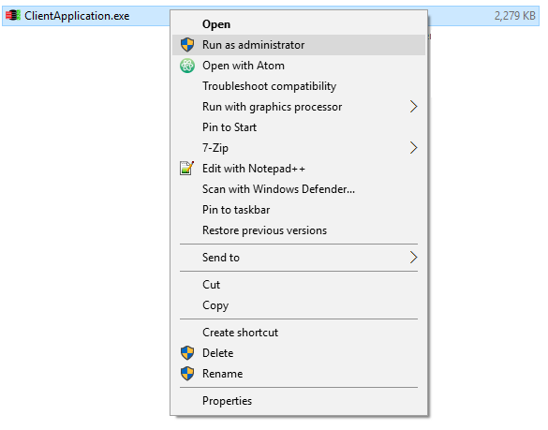

# Running the Application

## Step 1 : Start DBEvaluation on Client Database System. (Run the application under administrator account who has full access on SQL Server instance.)

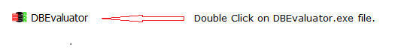

Initial screen it will appear immediately after this action.

## Step 2 : Initial loading screen.

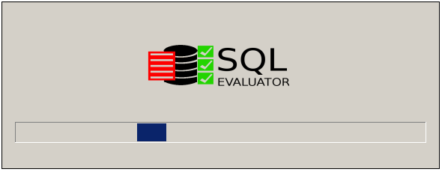

It will collect all the SQL Server instances details on the same domain network.

## Step 3 : Main Screen and SQL Server instance selection.

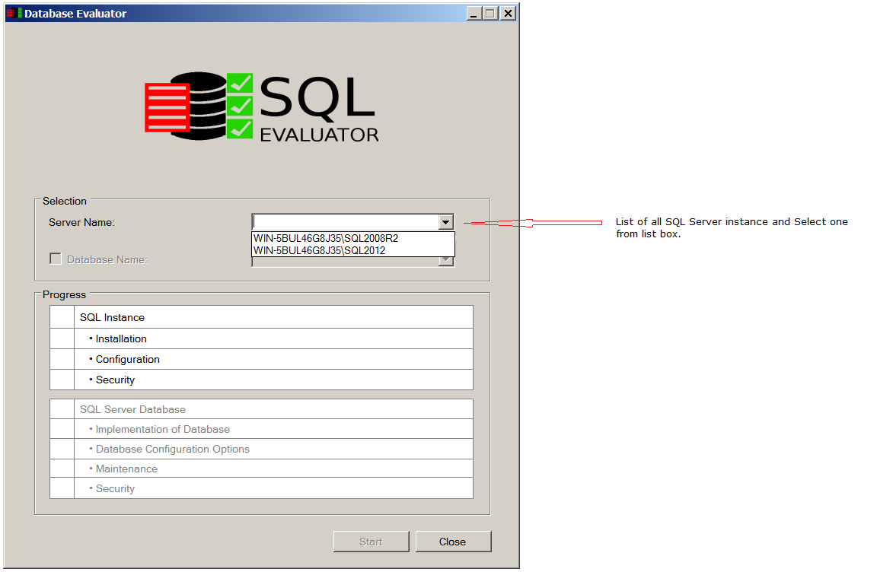

You can also enter the SQL Server instance name and press enter to connect.

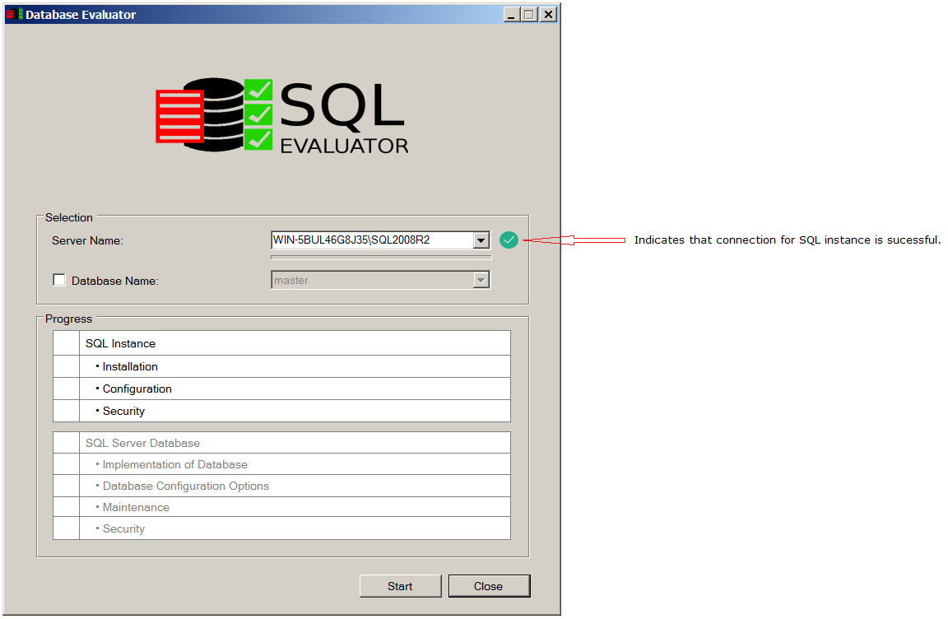

## Step 4 : User Database selection (Optional)

User can either evaluate SQL instance only or user can select at least one user Database to check.

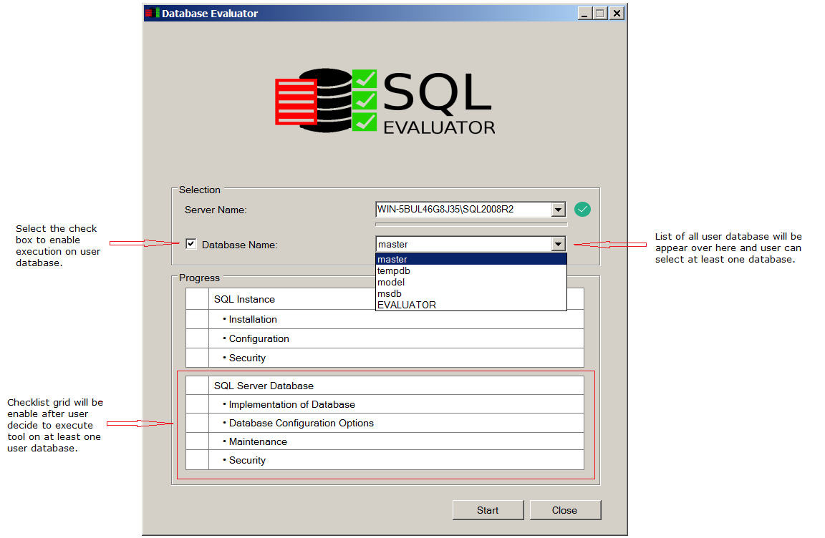

## Step 5 : Start gathering parameters values.

Click on Start button to start executing and collect the parameter values.

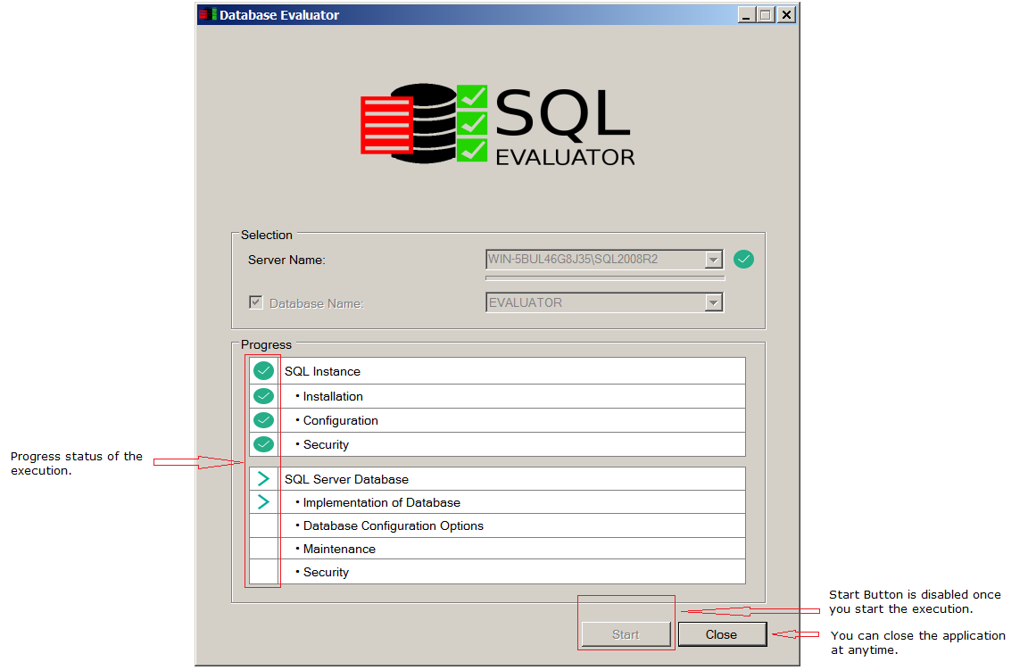

## Step 6 : Saving of dump file.

Application will ask you to save the dump file at the end of the execution. This dump file is encrypted and contains all the parameter values of the client database system.

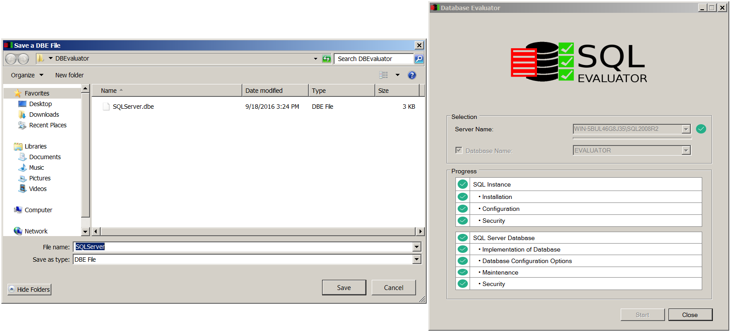

Website SQL Evaluator

1. First install any browser or open any browser installed in your computer like Mozilla Firefox, Google Chrome, Opera browser, Internet Explorer and many more.

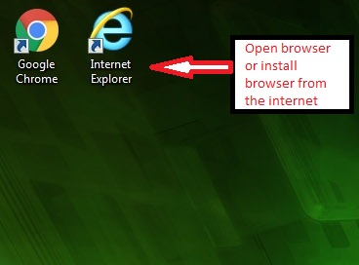

2. After you open the browser go to URL(Uniform Resource Locator) and type ***www.sqlstriker.com***

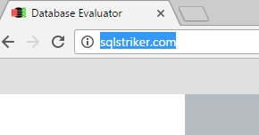

3. After you type the www.sqlstriker.com at the url, SQL Evaluator homepage for Guest User will show up it should look like this. The image will show the structure of the Home page.

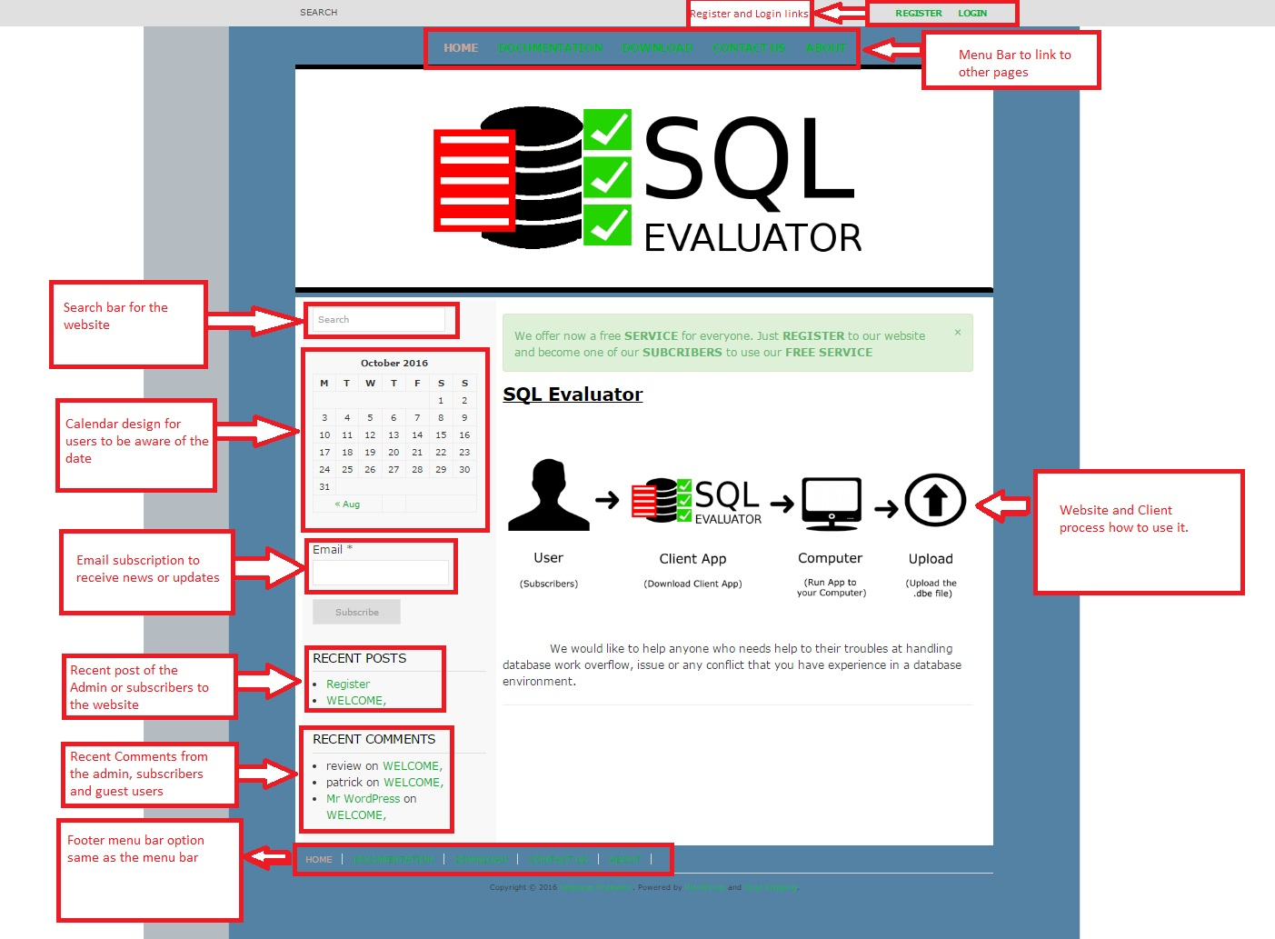

Register Login – are the links to the Register Page and Login Page to become a subscribers in using the website and the service.

Menu Bar – consist of 5 menus

* Home
  + What the page can do or to have an idea what the website is all about.
* Documentation
  + Documentation page will explain how to use the Client Application.
* Downloads
  + Download Page will be the page where you can download the Client Application.
* Contact Us
  + Contact Us will be about forms for inquiry for any question valid and active email add is a requirement to use the inquiry forms.
* About
  + About Page will explain the use of the software and who it is intended to.

SQL Evaluator Image Process – it explain how the process to use the client application.

Recent comments – will be about the comments that was posted by the admin, guest user and subscribers.

Recent post – are post that are created by the admin recently.

Search – is the function for searching any related content for the website.

Email – is a function to subscribe the email to be updated to any news about the website.

Foot Menu Bar – are links that are the same as the menu bar.

Calendar – is a calendar intended for user to be aware what the date is?

4. Beside the Home menu is the Documentation which will show the page for documentation how to use the Client Application.

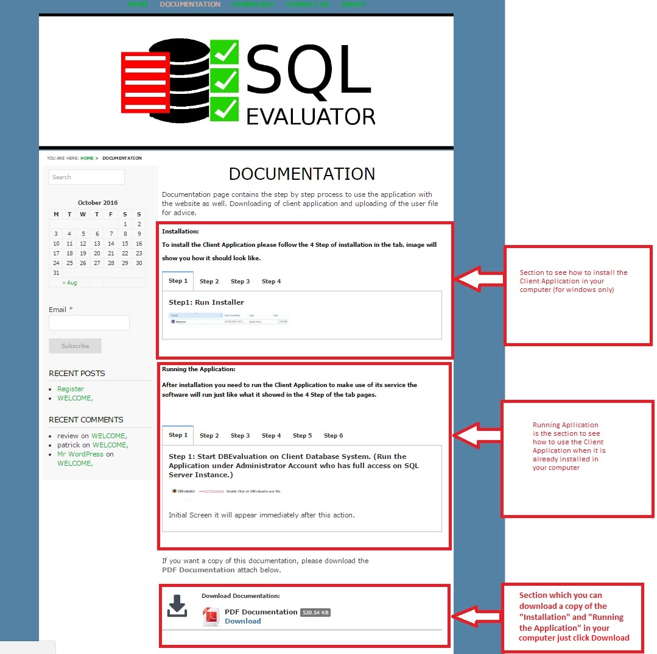

Installation – Will show you a tab gallery of the steps how to install the Client Application to your computer.

Running Application – Will show you how to run the application and how to use it after you installed the Client Application to your computer.

Download – will be the section wherein you can download a copy of the documentation in a PDF format to your computer.

Just click the Download text to download Client Application.

5. Beside the Documentation is the Download page where you can download the Client Application Installer to your computer.

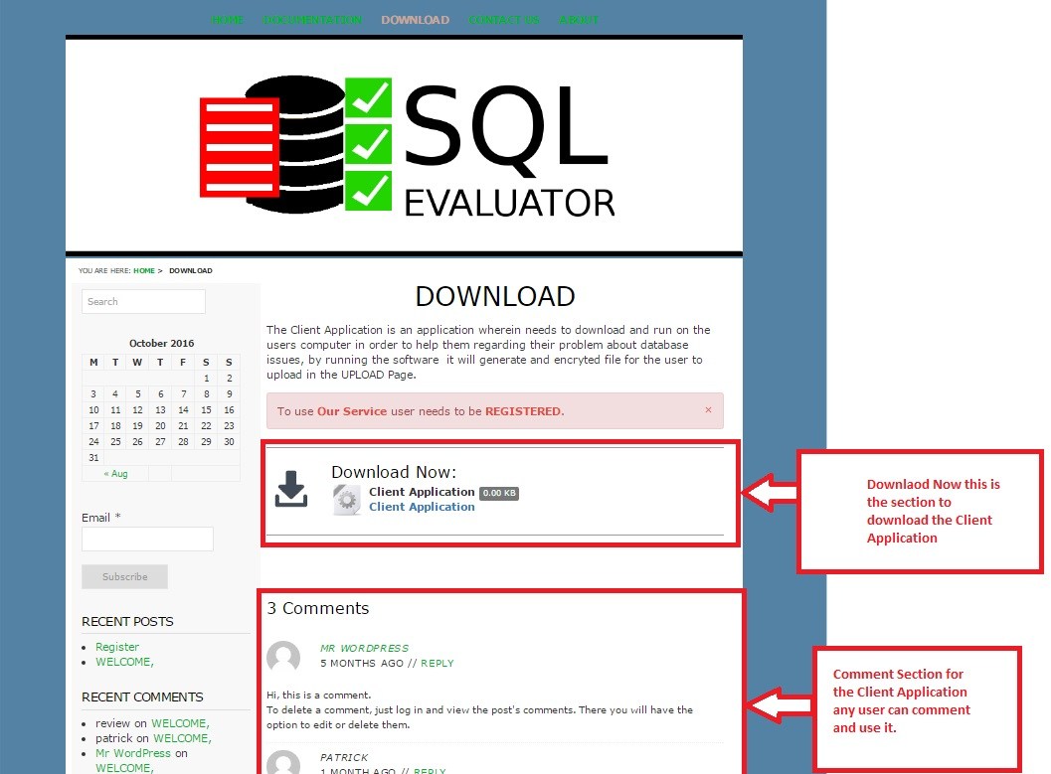

Download now – is a section for downloading the Client Application Installer to your computer just click **Client Application**.

Comment – for any user who want to comment about the software it’s an open user comment.

6. Next to Download Page is the Contact Us page where you can ask question by the admin of the website.

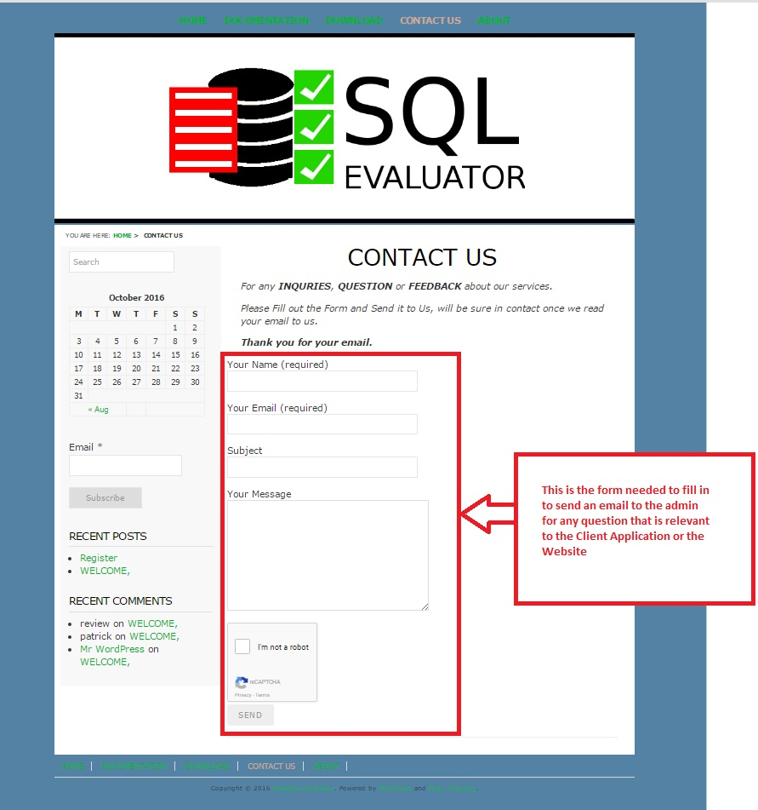

Contact Us Forms – The forms in the Contact Us page is an email form a valid and active email is needed to use the form and remember to use the captcha function to send your email and hit SEND button.

7. And last in the menu bar for the Guest User is the About Page.

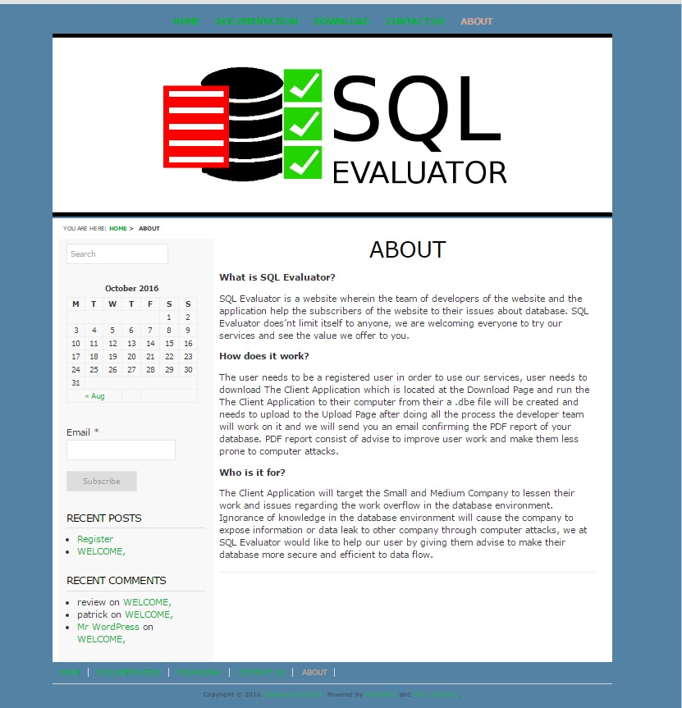

The About page explain and answer:

* What is the SQL Evaluator?
* How does it work?
* Who is it for?

8. Another links that is important to the website is the Register and Login link.

Register will need to fill in the **Username** and **Email** of the Register form.

Note: Valid and active email is needed to be registered in the website.

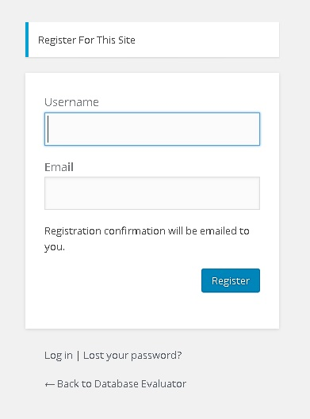

9. After the register an email for confirmation of the registration will be sent to the user email you have used to register for validation purposes.

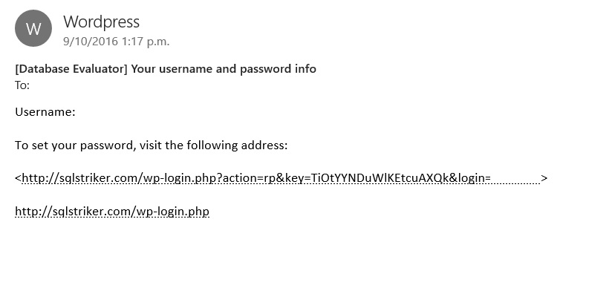

An activation key link for creating your password will be sent to you, to finalize the registration just click the link and put new password in the page that will show up.

10. Login link will display the Wordpress Login Page. To login to the website input the login credentials that have use to register in the website.

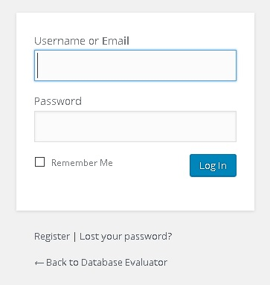

11. After the login the website will redirect the user to the subscriber’s dashboard and an additional menu will be added which is the UPLOAD menu in the menu bar and in the footer menu bar.

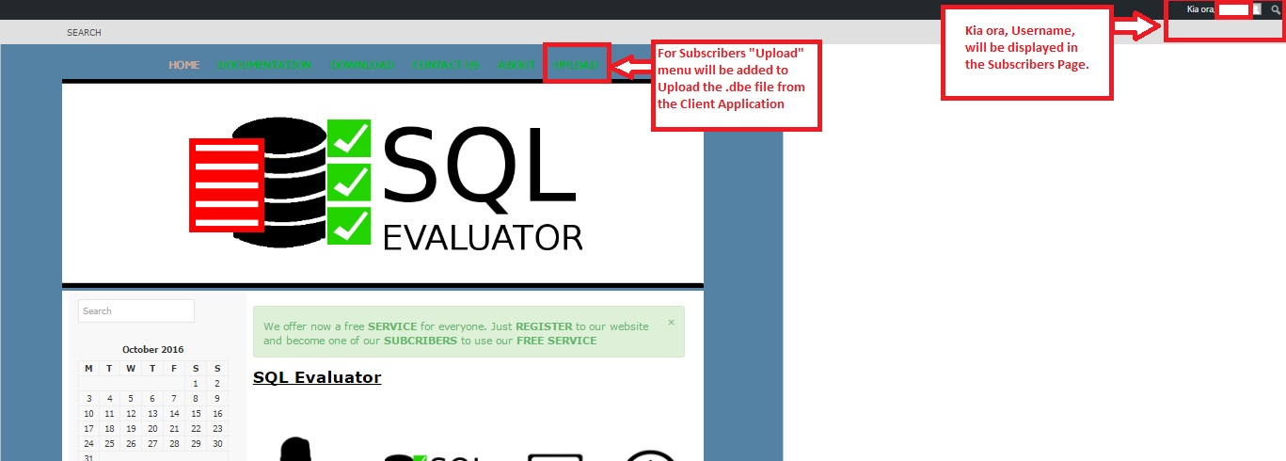

Upload Page – display the upload page of the where you can upload the .dbe file from the Client Application.

12. After the click of the UPLOAD link, the page for the UPLOAD will display and you need to select a .dbe file to be uploaded like what show in the image.

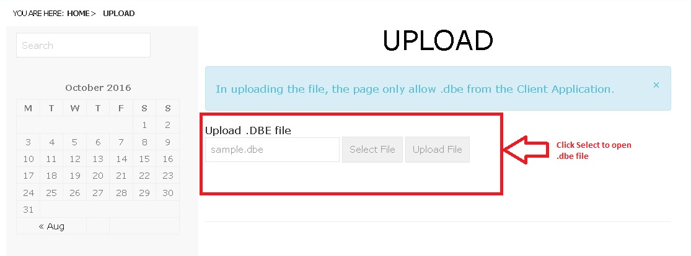

13. Select the .dbe file where the .dbe file from the Client Application created the file then Click Open.

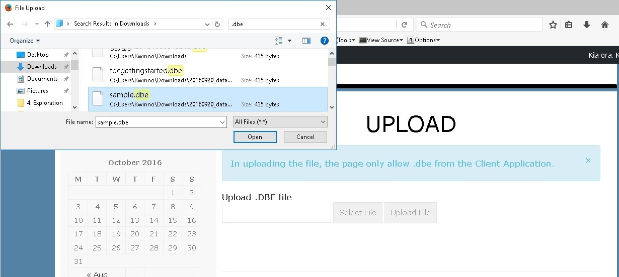

14. Next after the selected file Click Upload file which next to the Select File button.

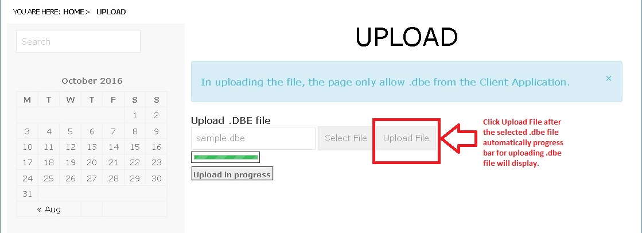

15. After the upload a confirmation message will be displayed to confirm if the file was uploaded.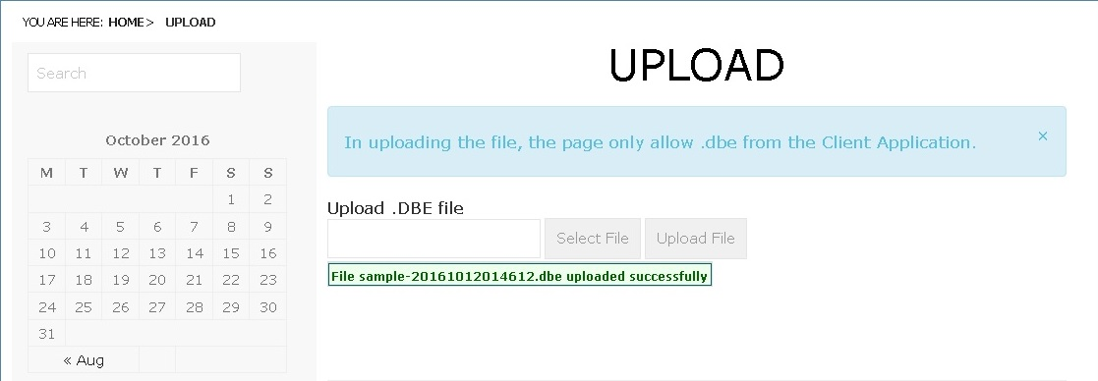

16. When the admin and the team of SQL Evaluator receive the .dbe request they will take care of it and create a report for the user an email with the link will be sent to the subscriber who uploaded the file.

Sample Email.

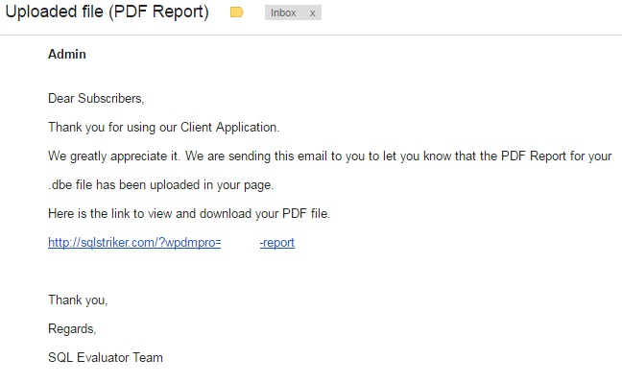

17. Here is a sample of a Table Report of a User after clicking the link from the sent email.

